Historically drinking water in Perth has been sourced from dams. Change climate over the past 50 years has seen the amount of water in dams drop from an average of 338 gigalitres per year (1935-1974) to an average of just 75 GL (2006-2010). This has reduced the security of dams as a source of Perth’s drinking water.
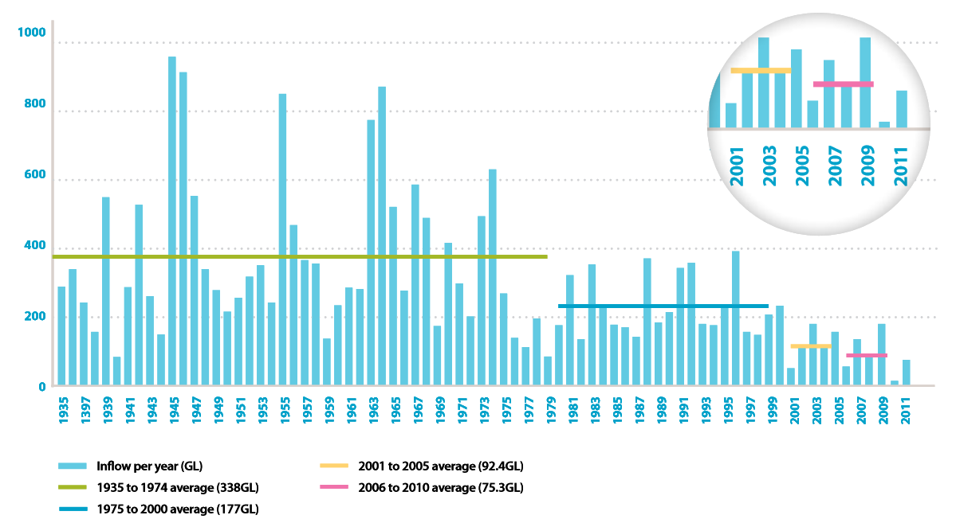

In response to changing climate, the Water Corporation has produced a 10 year strategy to transition away from dams as a source of drinking water (http://www.watercorporation.com.au/-/media/files/about-us/planning-for-the-future/perth-10-year-water-supply-strategy.pdf). Under this plan, it is hoped that all of Perth’s drinking water will be sourced from secure deep groundwater and desalination by the year 2022.

Extended Answer Topic:
Both groundwater and seawater are important water sources for Perth. Describe how these water sources are obtained and treated in order to produce potable drinking water. Your answer should include descriptions of major processes in the water treatment process.

You will have two computer sessions to research and in third session you need to complete your extended answer under test conditions. Your answer should be 1.5-2 pages in length. Your extended answer can include information in the form of text, tables and diagrams.

Research resources:
The Water Corporation has educational resources that will provide your with a starting point for your research. You may also choose to use other websites to extend your knowledge (e.g. to find additional information about certain processes which are mentioned).
- http://www.watercorporation.com.au/water-supply-and-services/solutions-to-perths-water-supply
- ‘How is your water treated’ (pg 27-29): http://www.watercorporation.com.au/~/media/files/about-us/our-performance/drinking-water-quality/annual-report-2013.pdf
- What is groundwater: http://www.youtube.com/watch?v=PTdHygICVaw
- Treating groundwater for drinking: http://www.youtube.com/watch?v=BSYA-1Ctb9g

To restrict Google searches to only include Water Corporation content, include site:watercorporation.com.au in the search term.

Name: ____________________________________________ Due: ____________________
CRITERIA | MARK | MARKS ACHIEVED
Introduction
Ground water- What is it? Where does it come from? | 2
Seawater- What is desalination process and what are the components of seawater? | 2
Body
Ground water
Processes involved in ground water treatment:
Steps | 1
Detailed explanation of steps | 10
Seawater
Processes involved in seawater treatment:
Steps | 1
Detailed explanation of steps | 6
Use of diagrams, graphs or tables | 2
Conclusion
Summary of information | 2
Structure
Use of headings, logical flow | 2
Quality of writing
Grammar, spelling and use of correct terminology | 2
TOTAL MARK
 | 30

